After reviewing this packet it is to be kept in the students ELA folder in their STRIPE.
How to survive …

Mrs. Berkowitz’s

3rd grade class!

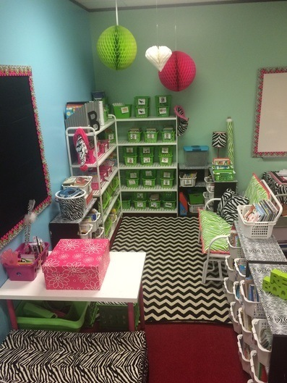

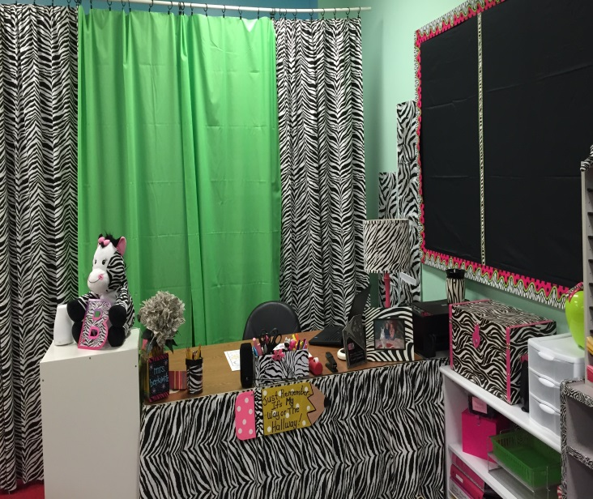

(Note that this guide also pairs with the class syllabus and by signing and returning the syllabus you are agreeing to the policies)
Classroom Guidelines
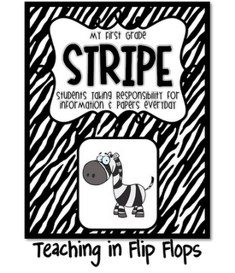

MY 3rd GRADE

Students Taking Responsibility for Information & Papers Everyday

What’s In a STRIPE?
First Paper: On the first page, you will find a copy of our weekly Daily Assignments & Homework sheet. After reviewing the day’s assignments with your child and making note of their behavior parents must sign the appropriate box. Please note the “check for” box. I will circle “check for” note if you need to check the lined notebook paper for a note from me. If you have written a note or placed money in the zipper pocket, please circle “check for” note &/or money under the appropriate day. The purpose of this is to check your students color for the day to address any behavior issues. Please know that an un signed STRIPE or if a student forgets their STRIPE for any reason – it will be a color change to yellow, as this is their #1 responsibility this year (even if it just so happens that the parent “forgot” to sign it). Note: On the back of this paper will be where your student is to keep track of their software weekly time (at least 60minutes a week)
2nd paper: This will be your student’s weekly reading log. Each night ONE section of the log must be filled in. All logs will be turned in on MONDAY mornings and students will receive a new one. Reading logs are a short assignment that should take a few minutes for students to complete after their nightly 20+min reading – this should not be a hassle in any way to complete.
1st Colored Pocket: In the front colored pocket you will find work “to be completed/reviewed”. These papers need to be completed & returned to school in the second pocket the following day: “to be returned” section. Please review homework with your child for careless mistakes. Thank You! Please note: If your child is bringing home a lot of work to complete each day, this is a sign that he/she is not using time wisely at school.
2nd Colored Pocket: In this pocket students will place items that need “to be returned” – any assignment or paper that you need the teacher to keep/grade/look over will need to be placed here
3rd Colored Pocket: This will be for ELA only and note pages will be kept here.
4th Colored Pocket: This will be for MATH only and note pages will be kept here.
5th Colored Pocket: This is the “take out and keep at home”/”graded work” folder. Any papers/items placed in this folder are to immediately be removed and kept at home. All graded work will be placed in this folder and are to be kept at home. Students will collect their graded work once a week from their mailboxes to bring home (Berkowitz only).
First Clear Sleeve FRONT/BACK: In the first clear sleeve you will find monthly newsletters. These newsletters will include skills to be taught & other important classroom information.
Second Clear Sleeve FRONT: Here you will find a schedule of our Specials Classes. This will let you know when your child needs to wear sneakers for PE or bring their library books to school.
Second clear Sleeve BACK: On the backside of this sleeve you, you will find the yearly school calendar featuring important dates to remember.
Third Clear Sleeve FRONT: In the front of this sleeve you will find a contact sheet with all important contact information.
Zipper Pocket: This is where you should put all money to be brought to school (lunch, book orders) so it doesn't get "lost" in the bottom of the backpack. This also is a good place to put doctor’s notes for absences or early dismissals.
Lined Notebook Paper: This is where you can write notes to the teacher & receive replies. Please write the date next to any communications you send, & be sure & circle that you sent a note on their Daily Assignment Sheet.

*Please note that parent signatures are to verify that you are aware of your students behavior from the day. The assignments listed are a guide but teachers may not follow it exactly depending on the days schedule.

EXAMPLE

Behavior:
- There will be a color chart where students will be able to “move” their assigned number to a certain color section dependent upon their behavior throughout the day:
  - Students can either move to a reward color or a consequence color
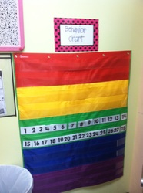
    - Green – Every student will begin the day on this color (this is average/expected behavior)
    - Yellow – This is the warning section (continued yellows will result in DPS points/loss of other privileges)
    - Red – This is the “last straw” & the student has had several warnings regarding behavior: a note will be sent home/parent contacted or possible discipline action may be taken by an administrator. (reds will also receive RPS points if warranted)
    - Blue – This is for students going above & beyond & showing integrity. The student will be given an extra ticket and allowed to choose 1 treat/coupon from the treasure chest.
    - Purple – AWESOME JOB! This is the highest a student can go & the student will then be given 2 extra tickets & allowed to go to the treasure chest/or choose 2 treats/coupons (PBS points will be given)
  - Please note: I strongly believe in teaching every one of my students the importance of responsibility & know that as 3rd graders they are more than capable of communicating & taking responsibility of their actions–please address any behavior issues or concerns with your student first (if further explanation is needed feel free to contact me).
  - *Recess/specials: Please note that if the whole class or select students choices result in a loss of recess and/or specials time than they will either sit out for a designated time or can choose to “work off” their time by doing a physical activity (this typically is the best option as it gives students a chance to release any extra energy that is usually the cause of the original misbehavior).
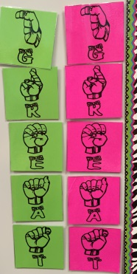
- Class signals:
  - Each day the class starts with all the letters in GREAT - as the class becomes disruptive a signal is taken down, if we make it through a day and keep at least one signal students will get a ticket. Loss of signals may result in loss of “extra time”.
  - Students can show one another and be good leaders by signaling to classmates which letter signal we are currently at by holding up the sign language letter (a wonderful way to prevent all the “shhh”ing”

- Class Dojo:
  - Another behavior system we will use is the electronic avatars in class dojo on our interactive smartboard/ipad:
    - This is an individual “point” based system in which students can earn points for being helpful and can also receive negative and loose points for misbehaving
  - The student with the most dojo points at the end of the week will be awarded a slushy from sonic the following week
  - Please check your student dojo points daily and address any negative points that are being issued.
  - Class dojo will be the main source of communication – make sure you have notifications turned on.
- Tickets:
  - At the end of the week I will draw from a bucket/”apple” that all of the students have turned their tickets into. The students’ ticket I draw will be the next star of the week and receive a slushy from sonic as well (Berkowitz only). (I draw a maximum of 2 tickets if the first one has already been star then they get 10 dojo points and I continue to draw until I have chosen a new star student) – if students are on red or yellow the day I draw then they are “disqualified” from the drawing.
Student Duties:
- I want to encourage my students to take responsibility & ownership of the classroom - to encourage this I will have a chart that will have classroom duties listed & each week I will rotate template name cards to the corresponding duty on the chart & students will be responsible for completing that job during the week – jobs are:
  - Line Leader
  - Door Holder
  - Filer
  - Pencil Sharpener
  - Gopher – runs “errands”
  - Librarians – in charge of organizing & keeping up with the classroom library
  - Trash patrol
  - Tidy Crew
  - Aesthetic assistant
  - Teacher assistant
  - Behavior chart monitor – moves all #’s to green every morning
  - Signal Monitor: This student will monitor the behavior & noise level of the class & decide whether or not the classroom behavior reward signals will stay or be taken down (losing all the signals results in the class not being awarded tickets for the next day to place in the drawing for a Sonic treat on Friday & for the next star student)
  - Technology team: In charge of turning on/off all devices and organizing Chromebooks
- The jobs will be applied for through applications and will be rotated throughout the year
Star Student of the week: (Please note this is only if time permits, academics take priority)
- Each week there will be a student of the week – rotating through everyone
- Every star is given their favorite slushy from sonic as a reward at the end of their week
- The student will be able to talk about themselves & bring things from home in order to create a show & tell experience during morning meeting – this will create community
- Also to encourage positive interactions each student will write a compliment & I will compile a compliments poster for the Star Student to take home with them.
Student desks:
- In my classroom I will require my students to keep their belongings & desks organized at all times. If students desks are a “disaster” then they will have to empty their containers and completely reorganize it before going to any special time.
- To help this I will arrange tables/desks in different color groups
  - Each group will have an organizer in the middle that is easily accessible to all the students.
    - The tray will have different sections for all supplies.
    - The different sections will have color coded supplies.
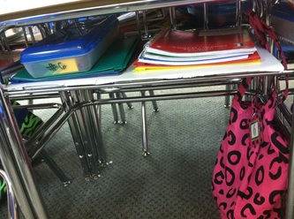
      - (D: pink, C: green)
      - Glue
      - Scissors
      - Markers/Hi-lighters
      - Colored Pencils
      - Pencils
      - Erasers
    - Each group will have a group monitor who is responsible for making sure that the organizer & the tables of the group are cleaned/organized & in tact
    - In order to keep books separate & organized each child has a “book buddy bag” in which they choose books from the classroom library to keep in the bag at their desk for easy access – all books are to be recorded in their reading journal, which is also located in the bag (books/buddy bags do not leave the classroom). My classroom books should never be brought home – if you happen to find one please promptly return it
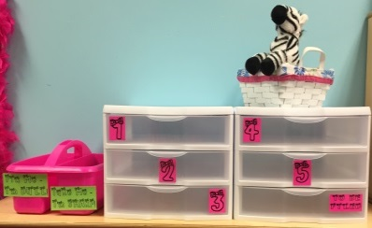
Grading/Filing:
- Work to be turned in:

  - Above the mailbox center described below there will be a set of drawer paper trays with a label declaring which tray is for which subject. Section D will turn items into the pink labeled drawers and Section C will turn items into the green labeled drawers.
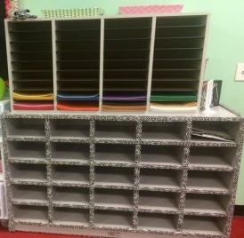
  - When students complete their work for the given subject they will turn the work into the corresponding tray of papers to be graded.
- Graded Work:
  - At the beginning of the year students will be assigned
a corresponding number – this number will be used for filing papers.
  - There will be a filling system/student mailboxes where graded papers will be filed back to the students – the system will be ran solely on the students numbers
    - This way students can file graded papers as a “duty” during free time & students grades won’t be public
  - Please note: I strongly believe in teaching every one of my students the importance of responsibility & know that as 3rd graders they are more than capable of communicating & taking responsibility of their actions – please address any grade issues or concerns with your student first (if further explanation is needed feel free to contact me).
  - If a student fails a daily assignment they may receive a “speeding ticket” and will need to work with the teacher during extra/special or recess time to correct their mistakes
  - If a student fails a major grade they will receive a test corrections sheet with the return date to receive up to a 70%. If students do not complete the corrections correctly or by the date given then their failing grade will be final.
- Late work:
  - Students will be informed that they must complete given assignments within one whole day (unless otherwise specified)
    - i.e.; an assignment that is given on Monday & not completed must be returned by Tuesday morning– all unfinished work will be placed in their STRIPE to be completed as extra homework for that night
  - If students do not turn the work in they will be given an incomplete grade/0 % until the work has been turned in. Every other Friday I will send home missing grade reports that must be signed by a guardian and returned on Monday (preferably with the students missing work) – this create student responsibility & management of their time/work. Please know that all late assignments will be deducted 10points per day the assignment is late. Students have access to extra copies of all assignments and are responsible for getting/turning in their work.
- Homework:
  - It will be given the first day of the week and collected on the last day of the week.
- Student work:
  - I will make it clear that any work without the students’ name (5points) & number (5points) at the top will result in a loss of points (10 points of final grade).
  - I will also outline that all papers will consist of the students number/section, the date & title of the assignment as well as correct side of the paper and all implemented strategies must be used in order to receive full credit (PRESTO and I.C.T.A.B)
  - If work is rushed through or handwriting is sloppy students will be required to re-do it or have points deducted: I will only except their best work
Take home work:
- Every week all students papers that have been filed will be collected & placed in their folders in which they are to take home & give to their parents who will take out & review papers - this will help parents to be aware of student grades. This should occur every Friday and is the students’ responsibility to relay work to the parent.
Lines:
- Students will be asked to line up in a variety of ways and will line up in # order during all classes throughout the school year.
Leaving the room:
- Students will be required to ask permission to leave the room for any reason & a pass must be taken with them at all times
  - This will help to make sure that no more than 1 boy or girl is out of the room at a given time
- Students are given multiple “breaks” throughout the day & need to use the facilities during those times – if they chose not to, they will then have a color change/ loss of dojos if they decide to go during crucial lesson time as they are missing important information
Attention Getter:
- I will have several attention getters that will require students to stop, look & listen immediately, these will be part of our Whole Brain Teaching Process
Listening:
- This will be one of the most important procedures that students will be held accountable for
  - Eyes on the speaker and mouth silent
    - If sitting: Hands on your lap and Pockets in the chair or floor (if floor legs criss-cross applesauce)
    - If standing: Hands by your sides and standing at attention like a soldier
  - We will also use Whole Brain Teaching practices to guide our listening/classroom rules, ask you student to explain the 5 rules
Schedule:
- There will be a schedule posted for students to see in order to help them know what is coming next & be prepared – parents may find a copy in the students STRIPE
  - I will also announce the schedule until it becomes familiar
Beginning of class procedure:
- Students will quietly come into the room & begin: BOC (beginning of class work) or engage in DEAR time
- I will call groups to turn in their STRIPES & take their “break”
  - Students then place all belongings in their lockers/desks & then continue working on beginning work or reading
End of class procedure:
- Students will silently continue working on desk work, unfinished assignments or DEAR time until groups are called to take their last “break” –
  - students will then clean everything up, use the restroom, pack up their belongings, color in their STRIPE based on the days behavior, pack up their STRIPE & silently read until the bell rings. Students will then form a line to be dismissed.
Tardy Policy:
- Students MUST arrive at school before 7:50am. Students who arrive after 7:50am are considered Tardy and MUST obtain a Tardy pass from the front office before coming into class. If your child had a medical appointment please obtain an “Excuse Slip” to excuse the Tardy or else it is considered unexcused. Please note that 10 tardies will be equivalent to 1 absence.

Arrival/ Dismissal Times Policy:
- Academic school hours/class times are 7:50am to 3:11pm. Students are expected to be in class at 7:50am, ready to learn. Dismissal time is at 3:11pm if your child does not have after school clubs or ZENITH (after school care). 3rd grade students are dismissed to the 3rd-4th Grade Dismissal Area at the front of the school. Students will be called by their dismissal number. Students will only be released by their assigned dismissal number. This is the same as the car sticker number assigned to each household. If you do not have an assigned car dismissal number, please notify the front office. Students who do not follow dismissal procedures may be issued RPS points by the teacher on duty.
Lunch Time Policy:
- 3rd Grade students have Lunch B from 11:40-12:10pm. There are designated tables available for students to enjoy lunch with their parents. Please send all items with your student before the start of the day, do NOT bring items for the front office to deliver (there is no guarantee that your student will receive the item in a timely manner). Please note that any teacher may issue a lunch detention depending on the students behavior.
Mandatory Uniform Policy:
- Students MUST wear their red uniform top every day with khaki, navy blue or black colored pants or shorts (to the knees). GIrls may wear skirts but it must cover the knees. Jeans may only be worn on Fridays WITH the current years Spirit Shirt. Jackets/outerwear MUST be a school jacket.
  - NOT ALLOWED: Capri pants, Cargo pants (pants with pockets on the knees), Shorts/skirts above the knees, leggings, jeggings, skinny bottoms, hoodies. Please refer to Student Handbook for more info on dress code.
  - NOTE: Students who do not follow dress code will be sent home to change clothes.
Flexible seating:
*A variety of learning environments that support personalization in the classroom. Comfort, choice, and learner ownership of space are key to developing effective environments. Varied seating options, technologies and lighting support more advanced/successful learning. Students will have the chance to earn flexible seating privileges in the classroom; however, each student/parent takes full ownership of the provided supplies by signing the syllabus. Please note that all items in the classroom were purchased with my own money and that students will be required to replace items that are broken/misused or send in the amount for me to purchase a replacement (please know this is also the case even if the infraction was an accident). In the rare event that this occurs parents will be notified of the broken item and the cost (parents can choose to order the product directly or send in money). This will need to be done within 3 days of the incident that caused the broken item. If you are not willing to replace items your student may break then please note that they are not allowed to use my flexible seating options on the syllabus that you return.

